Strategy Card | Fact Cluster | Purpose
Set one
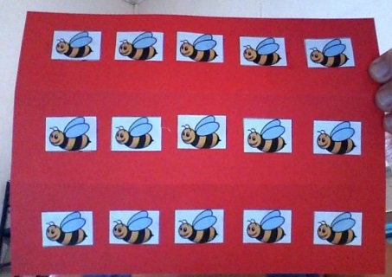  Counting (on and back) | X or /÷ by 5, 10 | 5 x 3 = 5, 10, 15  15 ÷ 5 = think X, 3 fives are 15 so 15÷5=3 or 5, 10, 15 so 3 fives are 15
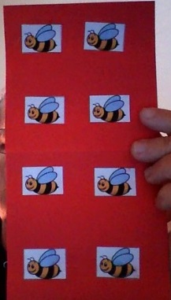Doubling/Halving | + numbers that are the same e.g., 2+2, 5+5  - ½ of any number e.g., 6-3, 8-4 etc | 2+2 = double 2 = 4  4-2= think addition double 2is 4 so half of 4 = 2
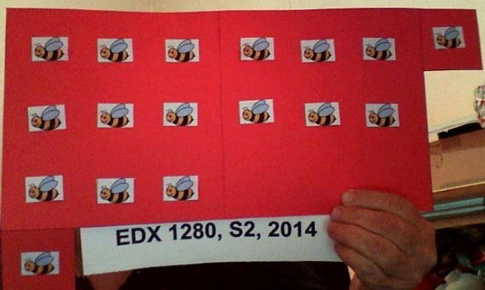  Use 10 | + or – 8 and 9 | Practise and reinforce the strategy for adding a number to 8 or 9 and subtracting 8 or 9 from a number >10 e.g., 9 + 5 = 9+1+6=10+6=16  16-6=16-10=6
Set 2
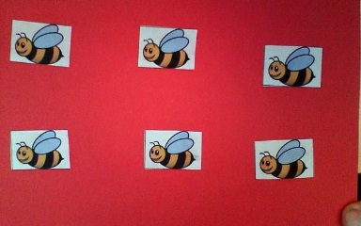  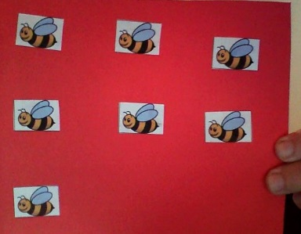  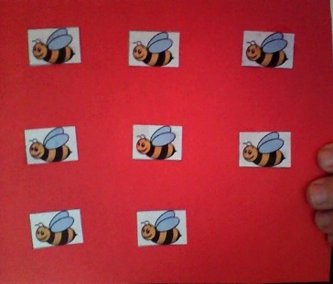  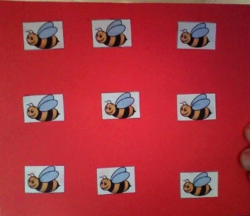Count On/Back | + or – 0, 1, 2, 3 | Adding or subtracting 0-3 from any number e.g.,6 + 3 = 6,7,8,9  9 – 3 = 9,8,76
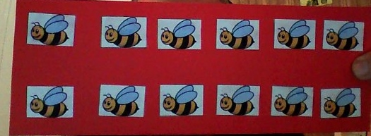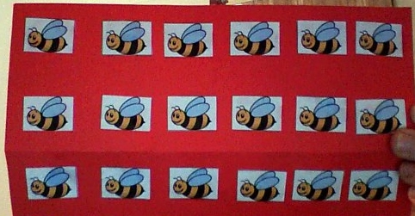Build Up / Down | X or ÷ by 6 | 3 x 6 = 2 x 6 + 6 = 12 + 6 = 18  18 ÷ 3 = think x, 3x6=18 so 18 ÷ 3 = 6
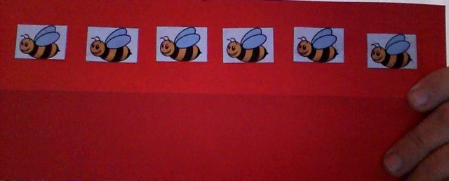  Think Real World | X and ÷ by 0, 1 | 6 x 1 = 6  6 x 0 = 0  6 ÷ 1 = 6  6 ÷ 0 = can’t be done  0 ÷ 6 = 0

- ACARA reference – When are the strategies introduced? Include the strand, sub-strand, content descriptor and elaboration as well as the specific ACARA reference number tag. Only 1 appropriate ACARA reference is required for Set 1 and 1 for Set 2. You do not need an ACARA reference for each card.
- Link to the language model – When are strategies introduced in the teaching sequence? When would you use these cards? Why would you use these cards? Specifically state the language step(s) at which these materials might be most appropriately used.

